**Lab 5: NMOS Common Source Amplifier (3% of total)**

**Objective:**

To build and test an NMOS based common-source (CS) amplifier to amplify small AC signals.

**Equipment and Components:**

* Breadboard, Power supply, Digital Multimeter, Function generator, Oscilloscope
* NMOS transistor (2N7002)
* Resistors (10kΩ, 3MΩ, 3MΩ, others per design)
* 3 Capacitors (47 *μ*F)

**Background:**

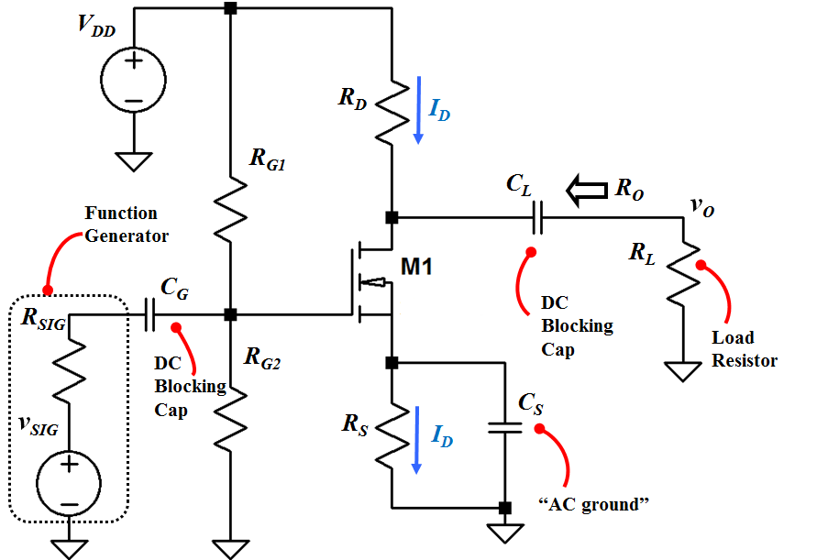

**Fig. 1 NMOS common-source amplifier circuit with coupling capacitors**

Fig. 1 shows an NMOS Common-Source (Source is common between Gate and Drain) amplifier circuit.

Note that ***vSIG*** and ***RSIG*** represent the ac signal source and its internal resistance, respectively. For the calculation and simulation purposes, you will include ***RSIG***; however, you will omit it in the actual circuit on the breadboard.

Coupling capacitors ***CG*** and ***CL*** block DC voltages. Here, ***CG*** blocks DC voltage, which is used to bias the gate, from entering the ac signal source. ***CL*** blocks DC voltage, which is to bias the drain, from appearing at the load. Ideally, if a small ac signal is applied at the gate we should obtain an ac signal at the drain with some amplification.

**Preliminary:**

1. Include your summary table and IV curve from the NMOS Parameter Measurements (Vt, Kn) Lab.
2. Show all the following steps clearly in your lab book.

***Design/ Calculate:*** *(*Use Example 5.10 as a guide, but note that we don’t have the feedback RG)

Design the amplifier circuit to achieve a small-signal gain of at least ***AV*** = -5 V/V and ***ID*** = 1 mA.

Use ***VDD***=15 V, ***Vt* = 2V**, ***kn*** = **78.5 mA/V2*, RSIG*** = 50 Ω, ***RL*** = 10 kΩ, and ***RG1*** = ***RG2*** = 3 MΩ.

**Part 1:** **DC Analysis**

1. Sketch the DC model of the circuit in your lab book.

***Note:*** Replace the capacitors with open circuit.

1. Calculate *VOV*, *VG*, *VS*, and *VGS*.
2. Determine the value of transconductance, ***gm.***
3. Find *RS*.

Note: At this stage, we know neither ***VDS*** nor ***RD***.

**Part 2:** **AC (small-signal) Analysis**

1. Sketch small-signal model of the circuit in your lab book.

***Note:*** Replace the transistor with its small-signal model, capacitors with short circuits, and *VDD* with an AC ground. What happens to *RS*?

1. Calculate *ro* (Use VA = 70V).
2. Label the gate of the transistor as *vi*, i.e. the small-signal voltage at the input. Find the ratio, ***vi /vSIG*** .
3. Derive the expression for *AV = vo /vi* . What is the value of *RD* that produces a small-signal gain of at least *AV= - 5 V/V*?
4. What is the DC voltage at the drain, *VD*? What region is the transistor operating in?

***Simulate:***

1. Using the values found above, and ***CG*** = ***CL*** = ***CS*** = 47 *μ*F, simulate the circuit.
2. Set the input *vsig* to 50mVpp, 1kHz with no DC component.
3. Record the DC values: *VGS, VDS*, and *ID*?
4. Determine *Av*.

**Procedure:**

***Note:*** You may need to adjust values of the components as necessary in the actual circuit in order to meet the design specifications, ***AVmin* = -5 V/V**. Also, you should not include ***RSIG***because it represents the internal resistance of the function generator.

1. Assemble the circuit using values from pre-lab.
2. Using a digital multimeter, measure the DC voltages at the gate (*VG),* source *(VS)*, and drain (*VD)*.
3. Using the function generator, apply an input ***vSIG*** of 50 mVpk-pk at 1 kHz.
4. Using oscilloscope, plot *v0* and *vi* vs. time.
5. Measure all the resistors to three significant digits.
6. Calculate *VGS, VDS*, and *ID* based on the above measurements.
7. What is the measured value of *Av* ?
8. What is the maximum gain that you can achieve without distorting the output signal?

*Optional:* Measure Ro as follows (it is important to know Ro so that you would know what the next stage or the load sees as the overall amplifier resistance.)

Replace RL with 1 MΩ resistor and repeat the AC measurements. Note the amplitude of the output waveform. Now adjust RL such that the output amplitude is 50% of what it was for 1 MΩ load. This new value of RL is the output resistance Ro.

1. How does it compare with your calculations and simulations? Note that this value of Ro cannot be greater than RD.
2. What is Rin (looking into the gate of the transistor)?

**Conclusion:**

1. Summarize the calculated, simulated, and measured results in a tabular form. The table should include the following parameters: *VGS*, *VDS*, *ID, and Av*. Explain any discrepancies.

*Get your summary table checked off by the instructor.*